Fellow Name: Michael Strezeski | Contact Info: strezemc@uc.edu | Date: 1/31/2016
Teacher Name: Dustin Hinson | School Name: Newport Middle School | Grade and Class: 8th Grade Mathematics

Activity Title: | The 6 W’s of Scientific Notation
Estimated Activity Duration: | 1 class period

Setting: | Classroom

Activity Objectives:
The student will be able to:
- Express numbers as a single digit times an integer power of 10.
- Use scientific notation to estimate very large and/or very small quantities.
- Compare quantities to express how much larger one is compared to another.

Activity Guiding Questions:
- How does multiplying by a power of 10 affect the value?
- What is scientific notation?
- How can a number be changed from standard to scientific notation?
- How is scientific notation used in the “real world”?

Next Generation Science Standards (NGSS)
Science and Engineering Practices (Check all that apply) | Crosscutting Concepts (Check all that apply)
☐ Asking questions (for science) and defining problems (for engineering) | ☐ Patterns
☐ Developing and using models | ☐ Cause and effect
☐ Planning and carrying out investigations | ☐ Scale, proportion, and quantity
☐ Analyzing and interpreting data | ☐ Systems and system models
☐ Using mathematics and computational thinking | ☐ Energy and matter: Flows, cycles, and conservation
☐ Constructing explanations (for science) and designing solutions (for engineering) | ☐ Structure and function.
☐ Engaging in argument from evidence | ☐ Stability and change.
☐ Obtaining, evaluating, and communicating information

Ohio’s New Learning Standards for Science (ONLS)
Expectations for Learning - Cognitive Demands (Check all that apply)
☐ Designing Technological/Engineering Solutions Using Science concepts (T)
☐ Demonstrating Science Knowledge (D)
☐ Interpreting and Communicating Science Concepts (C)
☐ Recalling Accurate Science (R)

Common Core State Standards -- Mathematics (CCSS)
Standards for Mathematical Practice (Check all that apply)
X Make sense of problems and persevere in solving them | ☐ Use appropriate tools strategically
X Reason abstractly and quantitatively | ☐ Attend to precision
☐ Construct viable arguments and critique the reasoning of others | ☐ Look for and make use of structure
☐ Model with mathematics | ☐ Look for and express regularity in repeated reasoning

Unit Academic Standards (NGSS, ONLS and/or CCSS):
The student will be able to:
- Use numbers expressed in the form of a single digit times an integer power of 10 to estimate very large or very small quantities, and to express how many times as much as is than the other.

Materials: (Link Handouts, Power Points, Resources, Websites, Supplies)
http://examples.yourdictionary.com/scientific-notation-examples.html
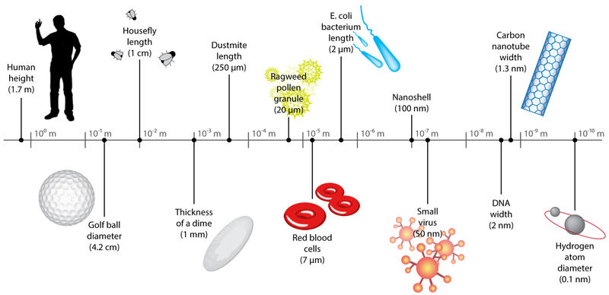

Teacher Advance Preparation:

- Distribute a pre-assessment to gauge student’s prior understanding of the subject.

Activity Procedures:
- Provide an introduction to the lesson. The introduction will use some commonly abbreviated words and sentences (text message jargon) to explain the concept of expressing large quantities using scientific notation. (Background Knowledge)
- Provide chemical engineering related example of a very large or small quantity (explain atoms and how they relate to everyday objects). Write the following examples on the board:
  - 7 x10⁹= Population of the world is around 7 billion written out as 7,000,000,000
  - 1.08 x10⁹= Approximate speed of light is 1080 million km per hour or 1,080,000,000 km per hour
  - 7.53 x10⁻¹⁰= Mass of a dust particle is 0.000000000753 kg
  - 9.1093822×10⁻³¹= Mass of an electron is 0.00000000000000000000000000000091093822 kg
(Research/ Background Knowledge)
- Ask students why these type of numbers are a problem. For further explanation, call on students and ask them to say the numbers out loud. When students struggle to articulate the values, explain that this is the reason why we need to abbreviate that number. (Identify Problem and Constraints)
- Ask students to take 1 minute to think about how we can abbreviate these numbers to make them easier to use. Then, ask students to get together in pairs and try to rewrite the numbers to make them easier to use. (Develop possible solutions)
- Have a group discussion about some of the answers they came up with and explain how scientific notation can be used to abbreviate those numbers. (Select a solution)
  - Explain the format of scientific notation. Two parts: 1. The coefficient (which must be a decimal between 1-10) and 2. The power of 10 (which must be a whole number).
  - Do one of the problems on the board as an example.
- Ask student’s to try to rewrite the numbers again in scientific notation. Go through the answers on the board to ensure understanding. (Test solution)
- Provide explanation of the engineering design process (EDP) and explain how it was used in today’s lesson. Mention that the last step is always to improve and redesign if needed (this step did not apply to our activity).
- If time permits, conduct an activity to help understand the scale of scientific notation using money.
  - Write out common monetary values on the board (penny, nickel, dime, quarter, dollar, etc.)
  - Have them provide you the number in cents.
  - Rewrite the numbers in scientific notation.
  - Explain how we can tell how much larger one is than the other (The coefficient indicates how many times bigger, a coefficient of 5.0 is 5 times larger than 1.0. Similarly, the power of ten value indicates how many orders of magnitude larger a value is.)
  - Ask students to tell how many times larger each one is.
- Conduct a short game to gauge student’s understanding and practice scientific notation problems. The game involves several basic problems, several half pieces of paper for each student, and a ‘basket’. Show the students the problem, ask them to write their answer and name on the piece of paper. Then, the students will wad up the paper and try to throw it into the basket. If the student makes a basket, then they will receive a ticket for the school’s raffle.
- Distribute post-assessment.
Formative Assessments: Link the items in the Activities that will be used as formative assessments.

- Have a group discussion about some of the answers they came up with and explain how scientific notation can be used to abbreviate those numbers. (Select a solution)
- Ask student’s to try to rewrite the numbers again in scientific notation. Go through the answers on the board to ensure understanding. (Test solution)

Summative Assessments: Prepare a Pre-Test and Post-Test with the input of the RET Teacher. This should be a simple 10-12 question assessment tool. These questions will cover the content related to the Standards. The Pre and Post Test will be identical. There may be several summative assessments at the end of this Activity. Besides the Pre and Post Tests, the students might create a product for which this is a rubric developed. The rubric is also a summative assessment tool. Link the assessment tools.

Unit 3: Scientific Notation

I can write large and small numbers in scientific notation.

1. | A scientist discovers a dinosaur bone that is 7 x ${10}^{7}$ years old. What is this number in standard form?
A | 7,000,000
B | 7,100,000
C | 70,000,000
D | 71,000,000
LT1

2. | A butterfly weighs only about 5.0 x ${10}^{-5}$ of a kilogram. What is this number written in standard form?
A | 0.00005
B | 0.000005
C | 50,000
D | 500,000
LT1

3. | Which is equivalent to the following? 0.000659
A | 6.59 x ${10}^{-4}$
B | 6.59 x ${10}^{4}$
C | 6.59 x ${10}^{0}$
D | 6
LT1

4. | Which is equivalent to the following? 45,300,000
A | 4.53 x ${10}^{6}$
B | 4.53 x ${10}^{7}$
C | 4.53 x ${10}^{8}$
D | 4.53 x ${10}^{-6}$
LT1

5. | Is 14.23 x ${10}^{8}$ in scientific notation? Explain?
A | Yes, it is correctly written in scientific notation.
B | Yes, it is in scientific notation because it contains 10 raised to a power.
C | No, it is not in scientific notation because it is not a large enough number.
D | No, it is not in scientific notation because the value left of the decimal is 10 or greater.
LT1

6. | Is 1.27 x ${10}^{6}$ in scientific notation? Choose the best explanation?
A | Yes, it is correctly written in scientific notation.
B | Yes, it is in scientific notation because it contains 10 raised to a power.
C | No, it is not in scientific notation because it is not a large enough number.
D | No, it is not in scientific notation because the value left of the decimal is 10 or greater.
LT1

 |  |  |  |  | Pre-Assessment Responses
Student | A | B | C | D |  | E | F | Score | %
AS | 3 | 1 | 1 | 1 |  | 1 | 2 | 4 | 67%
LK | 3 | 2 | 1 | 2 |  | 1 | 1 | 3 | 50%
MC | 4 | 2 | 1 | 1 |  | 2 | 2 | 2 | 33%
ED | 4 | 1 | 1 | 2 |  | 2 | 2 | 4 | 67%
Emma | 3 | 1 | 1 | 3 |  | 3 | 4 | 3 | 50%
AW | 3 | 1 | 1 | 2 |  | 4 | 3 | 5 | 83%
Tony | 3 | 1 | 1 | 2 |  | 2 | 1 | 4 | 67%
Joey | 3 | 1 | 1 | 2 |  | 2 | 1 | 4 | 67%
CE | 3 | 1 | 1 | 2 |  | 2 | 1 | 4 | 67%
Davon | 3 | 4 | 1 | 4 |  | 1 | 1 | 2 | 33%
CW | 3 | 2 | 2 | 1 |  | 3 | 1 | 1 | 17%
TS | 3 | 3 | 2 | 1 |  | 1 | 1 | 1 | 17%
CM | 3 | 2 | 3 | 3 |  | 2 | 3 | 1 | 17%
JB | 3 | 2 | 1 | 2 |  | 2 | 2 | 4 | 67%
JE | 3 | 1 | 1 | 2 |  | 4 | 2 | 6 | 100%
Andrew | 3 | 1 | 0 | 1 |  | 1 | 1 | 2 | 33%
AB | 3 | 2 | 3 | 1 |  | 2 | 2 | 2 | 33%
Total Correct | 15 | 9 | 12 | 8 |  | 2 | 6 |  | 51%

Post-Assessment Responses
A | B | C | D | E | F | Score | %
3 | 1 | 1 | 2 | 4 | 2 | 6 | 100%
3 | 1 | 1 | 2 | 4 | 1 | 5 | 83%
3 | 1 | 1 | 1 | 4 | 2 | 5 | 83%
3 | 2 | 1 | 1 | 4 | 2 | 4 | 67%
3 | 2 | 1 | 1 | 2 | 2 | 3 | 50%
3 | 1 | 1 | 2 | 4 | 1 | 5 | 83%
3 | 1 | 1 | 2 | 4 | 1 | 5 | 83%
3 | 1 | 1 | 2 | 4 | 1 | 5 | 83%
3 | 2 | 1 | 2 | 4 | 2 | 5 | 83%
3 | 2 | 1 | 2 | 2 | 2 | 4 | 67%
3 | 1 | 1 | 1 | 4 | 1 | 4 | 67%
3 | 2 | 1 | 1 | 4 | 1 | 3 | 50%
3 | 1 | 1 | 2 | 4 | 1 | 5 | 83%
3 | 1 | 1 | 1 | 4 | 1 | 4 | 67%
3 | 1 | 1 | 2 | 4 | 1 | 5 | 83%
3 | 1 | 1 | 2 | 4 | 2 | 6 | 100%
3 | 1 | 1 | 1 | 1 | 1 | 3 | 50%
17 | 12 | 17 | 10 | 14 | 7 |  | 75%

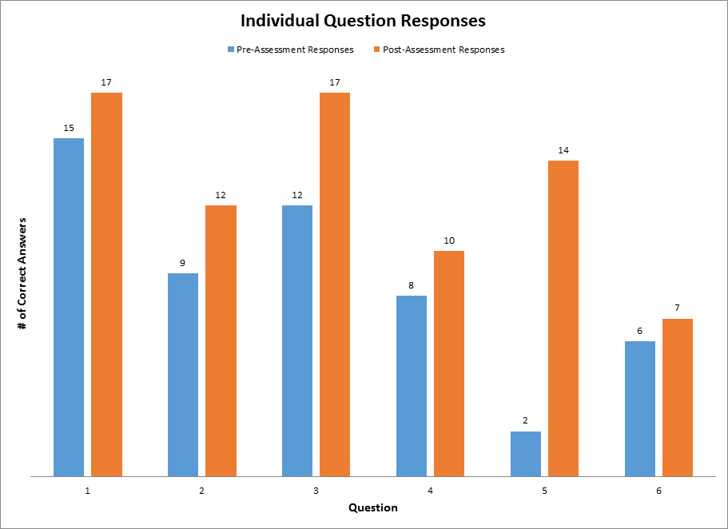

Differentiation: Describe how you modified parts of the Lesson to support the needs of different learners. Refer to Activity Template for details.

I included questions of all different levels of difficulty to ensure that students of all abilities will be able to participate in the lesson. Additionally, I prompted all students to participate and answer questions to ensure that the less social students felt engaged.
Reflection: Reflect upon the successes and shortcomings of the Activity. This is done after the Activity is implemented.

From the Pre-Test and Post-Test results, I can conclude that the students did learn a good deal from the lesson but there is some room for improvement. The results showed that the student’s average scores increased from 51% to 75%. A 24% improvement is a definitive sign of the student’s learning. On the test, there was one question in particular that did not show much improvement (question 6). I believe this is because there are two answers that are both technically correct. While one answer is “more correct”, it is understandable why some students would fail to see the difference. Overall, it appears that the students were able to understand the material and build a solid foundation for future lessons about scientific notation.

The lesson went pretty well considering my lack of experience in front of a classroom full of students. The first part of the lesson was used mainly to draw student’s interest in the topic. The students responded very well to this and appeared to be very interested. Next, I began to teach the students some of the concepts surrounding the lesson. I periodically checked to ensure that the students were understanding and they appeared to be following along. Then I began asking the students to provide me with examples and to solve problems on the board. This is where I experienced the two students that were comprehending more than the rest. After the two of them answered a few questions in a row, I stopped to look around and gauge the other student’s understanding. I quickly realized form their blank stares that I was moving too quickly. I was able to slow down and adapt the lesson to ensure that everyone was grasping the concepts at hand. After this, the students all appeared to be comprehending the lesson. Aside from that small setback, the lesson was generally well received and the students appeared to have learned a good deal from it.

